Filming yourself at home – A guide for public contributors
We’re excited to include your voice in our work! If you’ve been invited to record a short video from home, here are some simple tips to help you get started. You don’t need fancy equipment or technical skills—just a bit of preparation and a quiet space.

Before you start
- Check in with us first: If you're unsure about anything—how long the video should be, what to say, or how to send it—just ask! We're here to help.
- Keep it relaxed: Your video doesn’t need to be perfect. We want to hear your authentic voice and experience.

Setting up your space
- Background: Choose a tidy space without clutter (no bins or plug sockets in view). A simple wall or bookshelf works well.
- Lighting: Sit facing a window or light source so your face is clearly visible. Avoid having bright light behind you.
- Sound: Find a quiet spot where you won’t be interrupted. Do a quick test by recording a few seconds and playing it back.
- Camera: Your smartphone is perfect! Use the front-facing camera so you can see yourself. Prop it up on a shelf or desk so it’s steady and at eye level.
- Orientation: Unless we’ve asked you to film in portrait mode, please record in landscape (horizontal) mode. This works best for most platforms and editing.
- Framing: Make sure your head and shoulders are in the shot, and you’re looking directly at the camera.
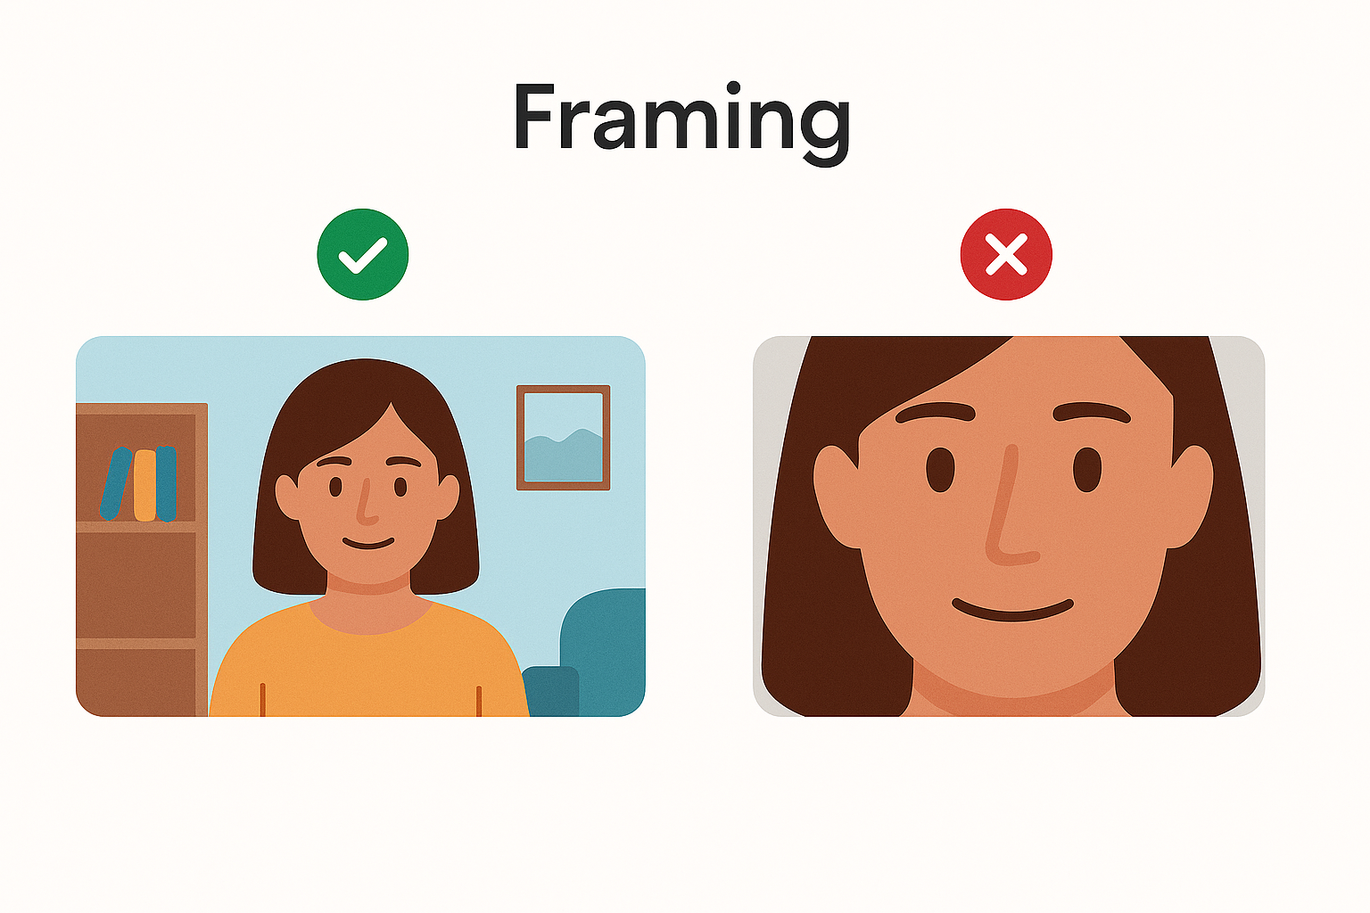

Speaking on camera
- Eye contact: Try to look at the camera lens—it helps viewers feel connected.
- Notes: If you need notes, keep them close to the camera.
- Tone: Keep it friendly and conversational—like you’re chatting with a friend.
- Length: We’ll provide specific guidance depending on the project, but generally, short and clear is best!

Sending your video
Once you’re happy with your recording:
- You can send it to us via email, or if the file is too large, you can use WeTransfer.
- If you record multiple clips, that’s fine—we can help edit them together.

Need help?
If you have any questions, just reach out. We’re here to support you every step of the way.

